LESSON PLAN FORM
student: Marloes Kraster coach: - date: group :KB number of pupils:21

BEFORE THE LESSON:
subject of the lesson:  Grammar lesson about the prepositions of place | summary of the previous lesson with this group:  The students played a game practicing the uncountable nous during the previous lesson. The students found this difficult at first, but gained a lot of knowledge during the game.
skills/knowledge pupils need for this lesson:  The students need to have knowledge about the different nouns and that a preposition is usually place before a noun. | lesson aims – what is it pupils are able to do or / what do they know at the end of the lesson:  - At the end of the lesson the students are able to include and use prepositions of place in sentences.
anticipated problems in teaching and learning:  The game element in the first activity “ A clear description of a picture” may cause chaos if the rules aren’t clear. | anticipated problems in this group:  In this class two children are diagnosed with ADHD and autism. For the boy with autism the rule have to be clearly explain otherwise is not able to participate.
personal learning aims for this lesson:

After this lesson I want to be able to motivate the students with an creative active activity. I also want to be able to arrange the classroom management in an effective way during a active cooperative activity after this lesson.

AFTER THE LESSON:
personal evaluation:  My lesson went well in my opinion and I had the feeling that the class clearly understood what was expected of them. I felt a little nervous in the beginning but this feeling cleared away while I was teaching. Due to my correct planning the lesson went as planned, there were no problems during the lesson. | to what extent have your personal learning aims been realized:  I have been able to motivate the students with an creative active activity, so this aim has been realized, but I feel like I have do some more work be able to arrange the classroom management in an effective way during a active cooperative activity after this lesson.
topics for “intervisie”:  How to react to difficult questions from your students. | new/adjusted personal learning aims:  After this lesson I want to be able to arrange the classroom management in an effective way during a active cooperative activity after this lesson.

THE LESSON:
Time | Sub aims | teacher activities | learner activities | lesson organization:  - indiv./pair/group work  - learning tools and media  - special circumstances
Intro: 2 min.  5 min.  3 min.  7 min.  5 min.  5 min.  10 min | Let the students enter the class calmly.  Activate the previous knowledge  Set a clear aim for the lesson.  They student can name the seven prepositions of place they learn today and are able to tell you what a preposition of place is.  Check if the knowledge of the prepositions of place has been received during your instruction.  After this instruction the students are able to work in pair of two or three on their activity.  The students learn to communicate in English with each other. | Greets the students and walks around. The PowerPoint with the beginning slight is visible on the board.  Looking back on the previous lesson:  What did we do?  What are countable nouns?  Let a student give an example.  Present your plan for today’s lesson and discuss the aim of the lesson with the students.  - Today’s aim is: After this lesson you are able to include and use prepositions of place in sentences.  - Explain what prepositions of place are  - Words indicating place  For example:  - On the table (place)  - When to use:  - are used to show the position or location of one thing with another.  Practice the seven preposition that they learn to day.  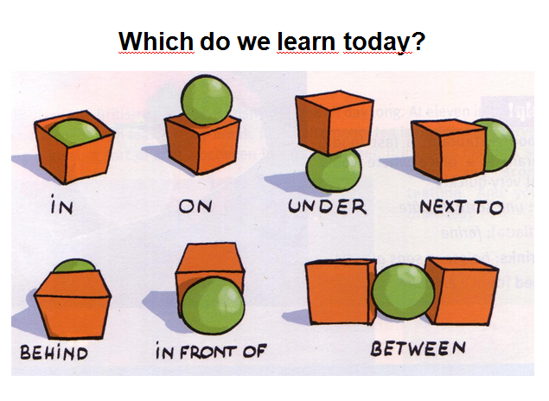  Read out all the prepositions and practice the prepositions out load with the students.  Let the students fill in the gaps:  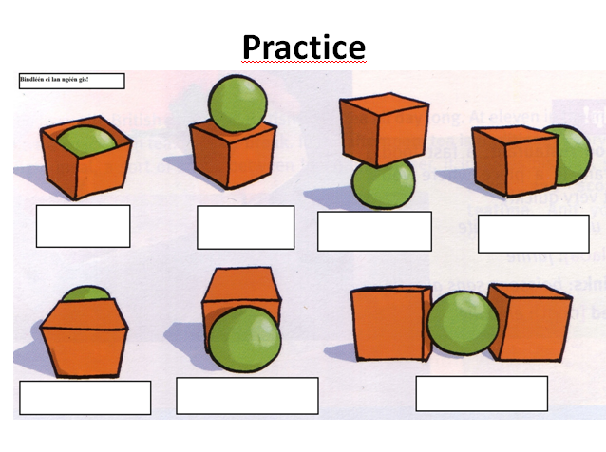  This activity is called a clear description of a picture.  - Draw a simple picture (individually)  - the students have to include four of the seven prepositions of place  - Work in pairs of two/three  - Describe the picture to a fellow student  - Example sentence:  - The cat lies under the table  - Example picture  The teacher walks around end helps were it is needed. | Are looking for a place to sit.  Activate their previous knowledge  The children learn why they have to learn this and when they might need this.  The students need to participate during the instruction and has to name the prepositions out loud when this is asked of them.  The students have to fill in the gasp when they are told to do this by the teacher.  - The students have to draw a picture individually ( 2 min.)  - Picture has to include four of the seven propositions of place.  - When they are all done they have to describe this picture to a fellow students. That students tries to draw the picture what the other students is describing.  The students work in pairs on their assignments. | - PowerPoint  - Individually    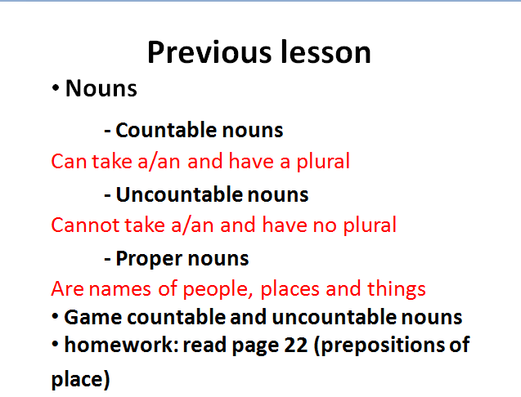  - Individually  - Individually  - PowerPoint  - PowerPoint  - Individually  - Together with the whole group, naming the prepositions  - PowerPoint  - Individually  - In pairs of two or three students  - PowerPoint  - Sheet of paper  - In pairs of two or three students
8 min. | The students are able to give a clear description of what they learned and did during this lesson. | Briefly discuss the activity:  What was difficult?  How did it go?  Sample test:  The students have to fill the gaps in the sentences on the board.  Briefly discuss this with the students:  How did it go?  Summarize the lesson of today  Evaluate the lesson with the students:  What did they learn?  Was it difficult?  Homework: read page 23 (prepositions of time) | The students make the sample test in their notebooks and correct their mistakes themselves.  They students can ask questions.  The students give answers to the questions the teachers is asking. | - PowerPoint  - Individually

